Rockville Pipeline Company

Customer Awareness- Cross Connections and Backflow Prevention

In our industrial world, many things present a potential source of pollution to our drinking water. Pesticides and herbicides that are used in agricultural and residential activities, mining, manufacturing, automobiles, and the list goes on. Because of this potential contamination to our drinking water, all water systems are required to take samples to be analyzed by a certified laboratory to determine if the water is safe for consumption.
But after all this is done, another hazard to our water exists in the form of Cross-Connections. These are simply physical connections that create a route between our drinking water systems and contaminates that might enter into the system. A common occurrence of a cross connection is a garden hose. If this hose is placed into a water trough for example, it then creates the potential for the water in the trough to be siphoned back into the system, should the pressure in the system drop below atmospheric pressure due to maintenance or failure of the water system because of a break in the main line, etc. This is referred to as “back-siphonage”. There are also other ways that undesirable or hazardous contaminates can enter into the system; Mechanical pumps that are connected to the system, and operate at a higher pressure than the system pressure, such as you find at car washes, can malfunction and pump back into the system. This is referred to as “backpressure”. Many devices exist today that can help protect these type of connections from polluting our drinking water. They form a physical barrier that, when properly installed and maintained, stop undesirable contaminates from entering into the water system. However, the most effective tool is an informed and conscientious customer who knows what to look for and how to eliminate these types of connections whenever possible.
The following pages provide some information and illustrations that will help you understand the different types of cross-connections, types of protection, and how we can prevent or protect against them.

If you have any questions concerning cross-connections within your system, please contact Rockville Pipeline Company by email: pipeline@infowest.com.

Appendix A

Partial List of Plumbing Hazards
Fixtures with Direct  Connections  Description  Air conditioning, air washer  Air conditioning, chilled water  Air conditioning, condenser water  Air line  Aspirator, laboratory  Aspirator, medical  Aspirator, weedicide and fertilizer sprayer  Autoclave and sterilizer  Auxiliary system, industrial  Auxiliary system, surface water  Auxiliary system, unapproved well supply  Boiler system  Chemical feeder, pot-type  Chlorinator  Coffee urn  Cooling system  Dishwasher  Fire standpipe or sprinkler system  Fountain, ornamental  Hydraulic equipment  Laboratory equipment  Lubrication, pump bearings  Photostat equipment  Plumber’s friend, pneumatic  Pump, pneumatic ejector  Pump, prime line  Pump, water operated ejector | Sewer, sanitary  Sewer, storm Swimming pool  Fixtures with  Submerged Inlets  Description  Baptismal fount  Bathtub  Bedpan washer, flushing rim  Bidet  Brine tank  Cooling tower  Cuspidor  Drinking fountain  Floor drain, flushing rim  Garbage can washer  Ice maker  Laboratory sink, serrated nozzle  Laundry machine  Lavatory  Lawn sprinkler system  Photo laboratory sink  Sewer flushing manhole  Slop sink, flushing rim  Slop sink, threaded supply Steam table  Urinal, siphon jet blowout  Vegetable peeler  Water closet, flush tank, ball cock  Water closet, flush valve, siphon jet
38 •
Appendix B

Illustrations of Backsiphonage
The following illustrates typical plumbing installations where backsiphonage is possible.  Backsiphonage  Case I (Fig. 44)  - Contact Point: A rubber hose is submerged in a bedpan wash sink.  - Causes of Reversed Flow:(I) A sterilizer connected to the water supply is allowed to cool without opening the air vent. As it cools, the pressure within the sealed sterilizer drops below atmospheric producing a  vacuum which draws the  polluted water into the sterilizer contaminating its contents. (2) The flushing of several flush valve toilets on a lower floor which are connected to an | undersized water service line reduces the pressure at the water closets to atmospheric producing a reversal of the flow. C. Suggested Correction: The water connection at the bedpan wash sink and the sterilizer should be provided with properly installed backflow preventers.  Backsiphonage  Case 2 (Fig. 45)  - Contact Point: A rubber hose is submerged in a laboratory sink.  - Cause of Reversed Flow:Two opposite multi-story buildings are connected to the same water main, which often lacks adequate pressure. The building on the right has installed a booster pump.






FIGURE 44.
A
B
B
B
A
B
Backsiphonage (Case 1).
FIGURE 45.
Backsiphonage (Case 2).

When the pressure is inadequate in the main, the building booster pump starts pumping, producing a negative pressure in the main and causing a reversal of flow in the opposite building.
C. Suggested Correction: The laboratory sink water outlet should be provided with a vacuum breaker. The water service line to the booster pump should be equipped with a device to cut off the pump when pressure approaches a negative head or vacuum.

Backsiphonage
Case 3 (Fig. 46)
- Contact Point: A chemical tank has a submerged inlet.
- Cause of Reversed Flow:The plant fire pump draws suction directly from the city water supply line which is insufficient to serve normal plant requirements and a major fire at the same time. During a fire emergency, reversed flow may occur within the plant. C. Suggested Correction: The

Backsiphonage
Case 4 (Fig. 47)
- Contact Point: The water supply to the dishwasher is not protected by a vacuum breaker. Also, the dishwasher has a solid waste connection to the sewer.
- Cause of Reversed Flow:The undersized main serving the building is subject to reduced pressures, and therefore only the first two floors of the building are supplied directly with city pressure. The upper floors are served from a booster pump drawing suction directly from the water service line. During periods of low city pressure, the booster pump suction creates negative pressures in the low system, thereby reversing the flow.
- Suggested Correction: The dishwasher hot and cold water should be supplied through an air gap and the waste from the dishwasher should discharge through an indirect waste. The booster pump should be equipped with a low-pressure cutoff device.

Backsiphonage
Case 5 (Fig. 48)
- Contact Point: The gasoline storage tank is maintained full and under pressure by means of a direct connection to the city water distribution system.
FIGURE 48.
Backsiphonage (Case 5).

B
A
Main
Gasoline
Water
FIGURE 49.
Backsiphonage (Case 6).
- Cause of Reversed Flow:Gasoline may enter the distribution system by gravity or by siphonage in the event of a leak or break in the water main.
- Suggested Correction: A reduced pressure principle backflow preventer should be installed in the line to the gasoline storage tank or a surge tank and pump should be provided in that line.

Backsiphonage
Case 6 (Fig. 49)
- Contact Point: There is a submerged inlet in the second floor bathtub.
- Cause of Reversed Flow:An automobile breaks a nearby fire hydrant causing a rush of water and a negative pressure in the service line to the house, sucking dirty water out of the bathtub.
- Suggested Correction: The hot and cold water inlets to the bathtub should be above the rim of the tub.

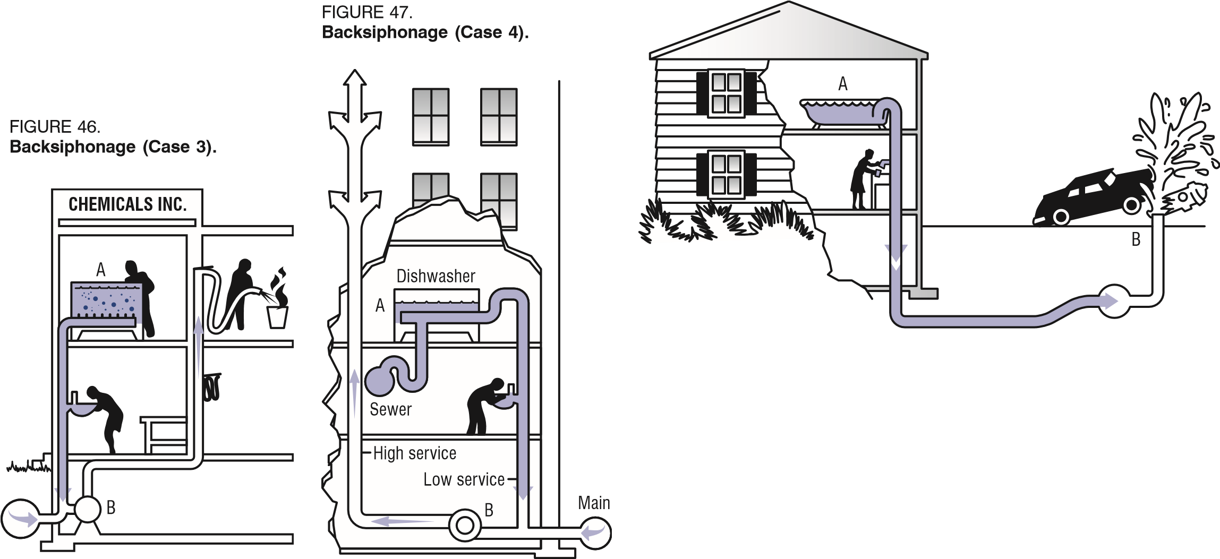
water service to the chemical tank should be provided through an air gap.
APPENDIX B • 39


Appendix C
Backflow
Case 2 (Fig. 51)
Backflow
B
A
FIGURE 51.
Backflow (Case 2).

Illustrations of Backpressure
The following presents illustrations of typical plumbing installations where backflow resulting from backpressure is possible.

Backflow
Case I (Fig. 50)
A. Contact Point: A direct connection from the city supply
to the boiler exists as a safety
measure and for filling the A. Contact Point: Sewage system. The boiler water system seeping from a residential is chemically treated for scale cesspool pollutes the private
prevention and corrosion control.  - Cause of Reversed Flow:The boiler water recirculation pump discharge pressure or backpressure from the boiler exceeds the city water pressure and the chemically treated water is pumped into the domestic system through an open or leaky valve.  - Suggested Correction: As minimum protection two check valves in series should be provided in the makeup waterline to the boiler system. An air gap separation or reduced pressure principle backflow preventer is better. | well which is used for lawn sprinkling. The domestic water system, which is served from a city main, is connected to the well supply by means of a valve. The purpose of the connection may be to prime the well supply for emergency domestic use.  - Cause of Reversed Flow:During periods of low city water pressure, possibly when lawn sprinkling is at its peak, the well pump discharge pressure exceeds that of the city main and well water is pumped into the city supply through an open or leaky valve.  - Suggested Correction: The
C. Suggested Correction: Each pier water outlet should be protected against backflow. The main water service to the pier should also be protected against backflow by an air gap or reduced pressure principle backflow preventer.
Backflow
Case 4 (Fig. 53)
- Contact Point: A singlevalved connection exists between the public, potable water supply and the firesprinkler system of a mill.
- Cause of Reversed Flow:The sprinkler system is normally supplied from a nearby lake through a high-pressure pump. About the lake are large
Case 3 (Fig. 52)  - Contact Point: A valve connection exists between the potable and the non potable systems aboard the ship.  - Cause of Reversed Flow:While the ship is connected to the city water supply system for the purpose of taking on water for the potable system, the valve between the potable and nonpotable systems is | numbers of overflowing septic tanks. When the valve is left open, contaminated lake water can be pumped to the public supply.  C. Suggested Correction: The potable water supply to the fire system should be through an air gap or a reduced pressure principle backflow preventer should be used.
opened, permitting contaminated water to be pumped into the municipal supply. | FIGURE 53.  Backflow (Case 4).



FIGURE 52.
ACME MILLS
Sprinkler
System
B
A






Backflow (Case 3).
connection between the well water and city water should be broken
A
B
City
main
Pump
To potable
system
FIGURE 50.
Backflow (Case 1).
Chemical feeder
B
A
40
•
Appendix D

Illustrations of Air Gaps
The following illustrations describe methods of providing an air gap discharge to a waste line which may be occasionally or continuously subject to backpressure.
2
xD
Pump
Ball check
Waste line
D
FIGURE 54.
Air gap to sewer subject to
backpressure—force main.
FIGURE 55. Air gap to sewer subject to backpressure—gravity drain.
2
xD
Indirect waste
Ball check
Support vanes
Horizontal waste
D
FIGURE 56.
Fire system makeup tank for a dual water system.
To fire system
Float valves
Nonpotable supply
2
xD
Potable supply
Appendix E

Illustrations of Vacuum Breakers
FIGURE 57.
Vacuum breakers.













Air enters here ^{Air}
Brass inset
Rubber sleeve
Air vent
contaminated liquids
Vaccum closes gate
Cowl nut
Flush connection
preventing rise of in fixtures
FIGURE 58.
Vacuum breaker arrangement for an outside hose hydrant.

Plan
“A”
“A”
Exterior
building wall
1
"
sleeve, sch. 40.
Hand wheel
I.P.S. hose adapte
r
Coupling M.I. galv.
Section “A” “A”
½
"
or ¾
"
Ell. m. M. I. galv.
½
"
or ¾
"
nipple galv.
½
"
or ¾
"
gate valve
½
"
or ¾
"
sch. 40. galv.
½
"
or ¾
"
vacuum breaker
(By permission of Mr. Gustave J. Angele
Sr., P.E. formerly Plant Sanitary
Engineer, Union Carbide Nuclear
Division, Oak Ridge, Tenn.)
APPENDIX E • 41

